FOUNDATION FOR VIRTUAL AND AUGMENTED REALITY SYSTEMS
Lecture30
Lec-30: Auditory Sense & Immersive Experience
Hello and welcome to the NPTEL MOOC's course on Foundations of Virtual and Augmented Reality Systems. We are going to continue our discussion on our auditory sense and the immersive experience. So, previously we talked about how sound is relevant for immersive experiences, what is sound, and how our auditory sense is structured. So, the physiology of our auditory sense.
In this lecture, we are going to learn about the other part of the discussion, that is auditory perception. How do we perceive something? and how it helps, how this knowledge helps to create immersive experiences in extended reality systems. So, let us first talk about sound perception. How do we perceive sound?
The first thing to know here is that we perceive sound at three levels. So, it is not that sound is just sound. one level understanding of sound. So, we perceive it at three levels: social level, warning level, and primitive level. So, these three levels of sound perception give us an overall idea of our surroundings: social level, warning level, and primitive level.
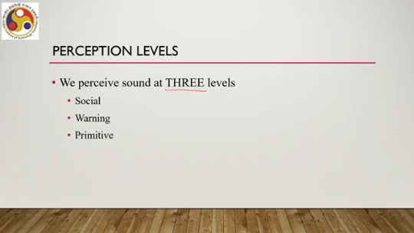
Let us talk about the social level. Now, perception that helps social interaction of individuals. So, when we perceive sound at a social level, essentially that perception helps us carry out social interactions with other individuals. Then the second level is the warning level. So,
This kind of sound perception provides us with an alert or warning about something. It may be some event or something, others, something else. So, that is the second level of sound perception. Thirdly, we have the primitive level. This is generally what we intuitively understand when we talk about the perception of sound.
That is perception of naive sounds like background noises that we tend to ignore mostly. So, when we are perceiving a sound, we perceive sound at a social level, at a warning level, as well as at a primitive level, although the primitive level understanding may not lead to any meaningful action on the part of the individual. We may ignore it. Now, when we are trying to generate sound effects in a VR system, say for example, a
Identification of the suitable perception level can help a developer generate suitable auditory effects. So, if for a particular system, social level perception is required, then we should pay our attention to generating that type of stimuli rather than stimuli that typically leads to primitive level perception. So, we first need to know what kind of perceptual effect is desirable and accordingly we should try to understand how to generate we should try to implement how to generate that effect.
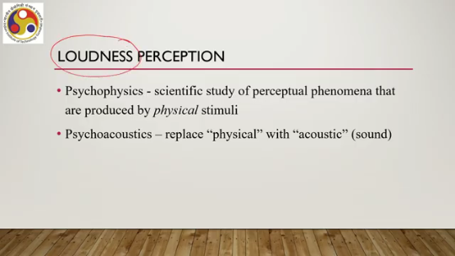
A related concept here is perception of loudness of sound so loudness perception. Now this understanding requires us to be aware of two related domains. One is psychophysics, the other one is psychoacoustics. So psychophysics is the scientific study of perceptual phenomena that are produced by physical stimuli. That is a broader definition.
Psychoacoustics is a more specific area of psychophysics where we can replace the term physical with the term acoustic. So in other words, Psychoacoustics is the scientific study of perceptual phenomena that are produced by acoustic stimuli or sound. Now, there is one famous law called Stevens' power law, which is one of the most well-known results from psychophysics. What does it tell?
It characterizes the relationship between the magnitude of physical stimulus and its perceived magnitude. So, actual magnitude of the physical stimulus, assuming that to be a wave, and its perceived magnitude, how these two are related. So, the relationship is represented in this form: P equals Cm to the power x, where M is the magnitude or intensity of the original stimulus. P is the perceived magnitude.
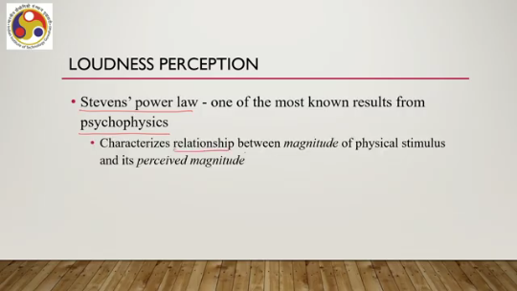
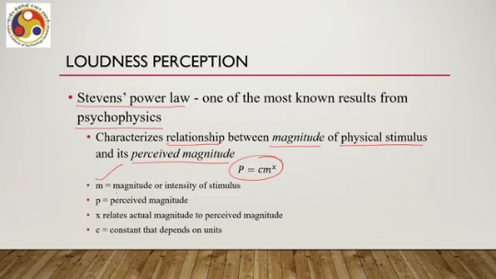
X relates actual magnitude to the perceived magnitude. And C is a constant that depends on units. So, this is called Stevens' power law to relate our perception to reality, to relate our perceived stimuli to actual stimuli. There is another important concept we should be aware of that is called just noticeable difference or JND.
This is another well-known result from psychophysics which says that the amount that the stimulus needs to be changed so that subjects would perceive it to have changed in at least 50% of trials. So, it refers to a kind of experimentation with some physical stimuli where the just noticeable difference indicates the amount of change in the stimuli which the subjects can perceive in at least 50 percent of the trials. Now, there is another law to capture JND, a just noticeable difference that is called Weber's law, which is represented as delta M by M equals C.
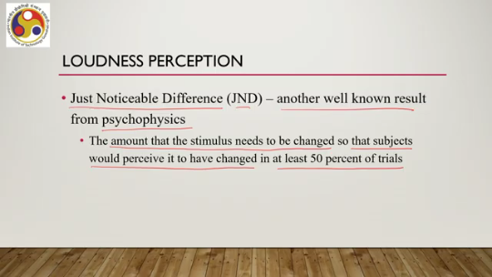
Here, M is the magnitude or intensity of the stimulus. Delta M is the just noticeable difference, that is the change in magnitude which is noticeable, and C is a constant. So, in other words, we can determine delta M as M times C. So, M multiplied by the constant. Now, both of these laws, Weber's law and Stevens' Power Law, these are
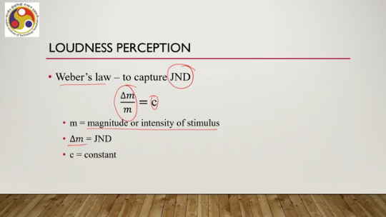
from psychophysics. However, as we have already seen, they are equally applicable to psychoacoustics or our auditory perception. So, if we replace physical stimuli with acoustic stimuli, then the laws will hold even if the nature of stimuli has changed. So, they are equally applicable to our auditory perception. The exponent for perceived loudness of a 3000 Hz pure tone is x equal to 0.67.
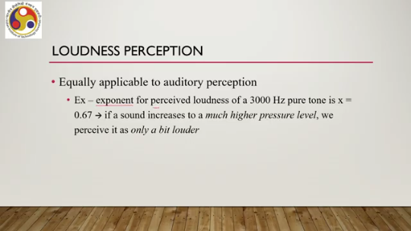
That is the Stevens' Power Law. This implies that if a sound increases to a much higher pressure level, we perceive it as only a bit louder as the exponent is less than 1. So, the perception P equal to C m to the power x. So, even if the physical stimuli changes to a higher degree, but perception-wise, that change will be much more moderate. That is what the power law tells. So then we can understand that to generate some effect, how much change we should try to make so that it is perceivable based on this type of psychophysical or psychoacoustic laws.
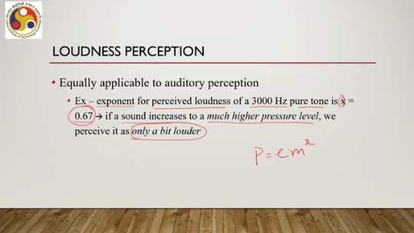
So such theories can inform us about other issues relevant for generating VR experiences. Equal loudness perception as a function of frequency that we can try to understand based on these laws. As the frequency varies, at what levels are the sounds perceived to be the same loudness? In other words, whether the varying of frequency will have any effect on our perception of the sound that is generated by the system. If we want the
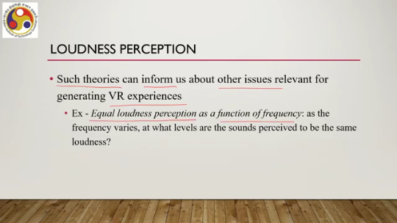
change to be perceived, then we have to have the change above just noticeable difference. If we do not want it to be perceived, then of course it has to be within JND or below JND. That is about loudness perception and the corresponding psychoacoustics or psychophysical theories. Another perceptual thing is pitch perception. So, sound perception we can perceive at different levels. Then loudness perception we can make use of the theories.
Similarly, for pitch perception, when considering perception, the frequency of a sound wave is referred to as pitch. And for frequencies less than 1000 Hz, humans can detect a change of frequency less than 1 Hz. So, the discrimination ability decreases as the frequency increases. At 10,000 Hz, JND is about 100 Hz.
So, the lower the sound frequency, the higher the chances that we will be able to differentiate between two frequencies with a much smaller JND. The higher the frequency, the chances are lower that we will be able to differentiate between two frequencies with a smaller JND. So, there the JND itself will increase. So, in terms of percentages, this means that pitch perception is better than
a 0.1% difference at low frequencies. So, at low frequencies, even if the frequency difference between two sound waves is less than a very significant amount, say even 0.1%, we will be able to notice the difference. However, if the frequency increases, then it will be difficult with such a small difference. In that case, we require a higher difference in frequencies to be able to differentiate two sound waves.
So, at least 1 percent higher. That is about pitch perception. So, we are trying to understand perception of sounds at different levels. So, first, overall sound perception can be thought of as, can be done at three levels: social, warning, and primitive.
Then when we are talking about loudness perception, we can make use of the theories, well-established psychophysical or psychoacoustic theories, to design systems. Similarly, for pitch perception, there is another interesting thing about sound perception that is called localization. Now, this is one of the main areas of psychoacoustics, and it deals with estimating the location of a sound source by hearing it. So, when we are hearing it, how do we perceive from where the sound is coming? This is crucial for many VR experiences, particularly to give a better idea of orientation and position of other objects with respect to the user's position.
Let us try to understand it in terms of an example. Now, if people are socializing, then their voices should seem to come, or in other words, should be perceived as coming from the mouths of the corresponding avatars. Suppose you are designing a virtual reality environment, which is a networked social environment. That means multiple users can participate. in the experience simultaneously.
We talked about that type of experience earlier. And one way to make them participate is by creating individual avatars. So, you will be seeing multiple avatars in your virtual space, each avatar representing one user. Now, when these avatars are talking to each other or talking to you or your avatar, You as a user should be able to perceive from where the sound is coming.
You should be able to perceive that when a particular avatar speaks, that sound is perceived to be coming from the mouth of that avatar. Now, this is called localization to determine the source of the sound upon hearing it. Why is that required? In order to match the auditory and visual cues and remember that unless this match is there, it may lead to several problems including break in presence as well as cyber sickness in different contexts.
Any kind of sound effect, such as a car or a zombie approaching, should also have matched cues. So, when a car is passing by in a virtual world, the sound generated by the car should be perceived as coming from that car rather than from some other direction. These are very crucial considerations to have a better immersive experience. Now, the JND concept applied for localization. We can apply the just noticeable difference concept for localization as well.
To obtain the minimum audible angle or MAA. So, this is defined as the minimum angular variation that can be detected by a human listener, and this can be visualized or represented in a spherical coordinate system. With the listener's head as the origin. So, there can be three different parameters here. One is the azimuth, as you can see in this accompanying figure.
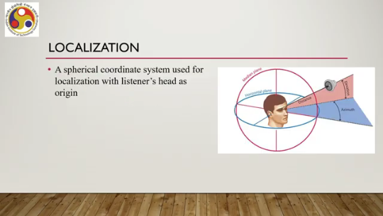
This is the angle in the horizontal plane between the forward direction and the source of the sound. So, this is the sound source. This is the forward direction, and this is the azimuth, the angle between the forward direction and the source of the sound, that is, the vector projected on the horizontal plane. The angle formed by the vector source direction's projection on the horizontal plane and the forward direction vector. Since our
Perceptual range is 180 to minus 180 to 180 degrees, this range. So, this azimuth angle can be between minus 180 degrees and 180 degrees. Then we have elevation. So, one is azimuth, the other one is elevation, that is the angle corresponding to the deviation of source from the horizontal plane.
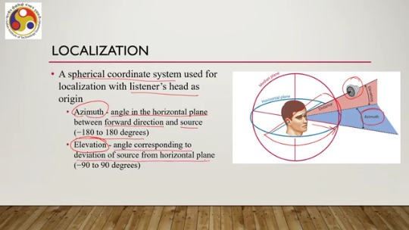
This is elevation, the angle between the actual source direction and the horizontal plane. It can vary between minus 90 degrees to 90 degrees. And the third parameter is the radius or distance from the origin to the source. Origin of the reference frame that is the human head, the listener's head, and the source is called the radius. So, with this type of representation of the entire perceptual setup, we can compute the various things related to localization.
including MMA. Now, MMA depends on both the frequency and direction of the source. At some frequencies and locations, MMA is down to 1 degree, a very small value. Whereas, at other combinations, localization can be very difficult and the MMA can be extremely high.
Now, for localization, we can rely on localization cues. Now, there can be different cues: monaural involvement of a single ear to perform localization, and binaural, where both ears are involved. So, either we can deploy one ear for localization or we can deploy both ears. Now, when we are talking about both ears, binaural cues, one important cue is the ILD or interaural level difference. So, this is the difference in sound magnitude as heard by each ear.
For example, one ear may be facing a sound source while the other is in an acoustic shadow. So, in that case, the magnitude will be different. So, now, acoustic shadow means the wave is not reaching the other ear. It can be caused by an object in front of the source and, of course, our head position.
So, in such cases, interaural level difference can act as a cue to tell us from where the sound is coming. So, because in that case, the closer ear which does not have any obstruction would receive a much stronger vibration or sound wave as compared to the other ear. So, this is one important cue. There can be another cue, that is interaural time difference.
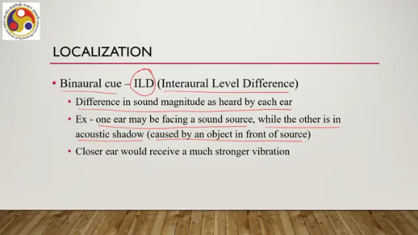
So, earlier one was level difference, now time difference due to difference in sound arrival time to each ear. Now, the distance between two ears for an average human head is 21.5 centimeters. So, different arrival times of sound from a source is source will be there because there is a distance. Sound travels 21.5 centimeters in about 0.6 milliseconds, which is a very small difference, but still it has been found that such time difference can be utilized for localization.
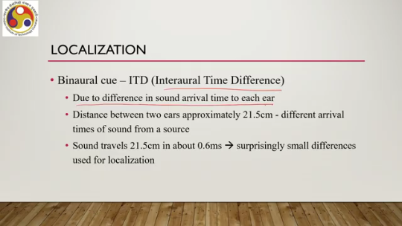
At what time instance sound is reaching each of the ears, based on that our head is able to perceive the source. to locate the source. So, these are some of the important considerations when we are trying to perceive sound: the sound perception levels, loudness perception, pitch perception, and localization. These four are broadly what are relevant for sound perception when we are dealing with immersive experience. The next issue is how we can render sound in
extended reality environment. Now the auditory component of our XR system should be ideally non-stationary, that is moving with the user, and interactive, that means dependent on the listener's actions. Ideally, these are the things that we want in our XR systems. Now there is an important concept called HRTF, which stands for head-related transfer functions. It models how we receive sound from a location in space.
That model is relevant when we are trying to deal with sound in any system including XR systems. Now a pair of HRTF for both ears can be used to synthesize binaural sound. And it depends on the size and shape of the head, ears, and ear canal. Now, the catch is every person has a unique HRTF. So, when we are building a system, it is impractical to determine HRTF for individual users.
Instead, what we can do is we can develop HRTF for an average listener. And that is the approach used. And based on the HRTF, sound effects are generated or received, or the sound receivers are placed accordingly so that localization effect can be implemented along with other perceptions, of course, which are part of the sound system that is part of any XR system. So in summary, what we can say is that in this lecture we have covered broad concepts related to sound and its role in immersive experience.
So we have learned about or talked about the importance of sound in XR. Then we have gone through the physiology of our auditory system, that is how our ears are made. Then we talked about how we perceive sound. There we learned about different levels of perception: social level, individual level, warning level, primitive level. Also we talked about loudness perception, we talked about pitch perception, and we talked about localization, determining the source of the sound which is a kind of perception.
Then we briefly talked about how to include Sound: what are the ideal things that we expect? And ideally, we expect localization to be implemented. For that, we need to implement HRTF - head-related transfer functions. Generally, that is done for the average human user rather than individual users, although there is individual variation in HRTF. So, this is how to render to get the best experience, as we have also talked about. Note that although we talked about only HRTF, when we are having a sound system embedded both as input and output, particularly output, the generation
of sound must take into account the level, whether social, warning, or individual, or combination of them, loudness perception, pitch perception, and localization altogether, and generally that is done. So we have covered visual senses, we have covered sound senses that we can deploy for better immersive experiences. A few more senses are left, that is taste, smell, proprioception, and so on. Now we are going to talk about those, also touch; we are going to talk about those in the next lecture, that is understanding other sensory systems and their role in XR experience.
Most of the material I have covered in this lecture is taken from this reference. If you are interested, you can go through it and learn in more detail about the topics that I have covered, particularly chapter 11. I hope you are able to follow the lecture, follow the topics, and could understand the topics and the discussion. Looking forward to meeting you in the next lecture. Till then, goodbye, thank you, and happy learning.
